# CANOPY WITH FIXED ROOF

## Manufacturer

RENSON Sunprotection-Screens nv, Kalkhoevestraat 45, 8790 Waregem – Belgium  
Tel. +32(0)56 62 71 11, fax. +32 (0)56 60 28 51, [info@renson.be](mailto:info@renson.eu), [www.renson-outdoor.com](http://www.renson-outdoor.com)

(texts in red may be removed according to your choice)

## Description

Algarve® Canvas is an aluminium patio canopy with a horizontal roof, featuring an upper roof of profiled sheet steel and an aesthetic ceiling of fibreglass fabric stretched tight. The canopy is placed freestanding or mounted on a façade and is supported by vertical columns with concealed screws.

## Dimensions

Span: Min. 800 mm  
 Max. 4500 mm

Pivot: Min. 895 mm  
 Max. 6055 mm

Free passage height: Max. 2800 mm

Total height: Free passage height + 230 mm

Coupled:

2 roof elements are coupled together via the pivot side in order to achieve a longer span side.

No extra column has to be placed between both roof elements.

Span per roof element: Min. 1500 mm  
 Max. 4500 mm

Span (sum of 2 roof elements) Min. 3000 mm

Max. 6000 mm

For information:  
The span side corresponds with the width of the sheet steel  
The pivot side is the side along which the various sheet steel elements are placed

## System version

### Type of installation

* Freestanding:
  + Freestanding, 4 columns
  + Self-supporting structure
* Façade mounting:
  + With one or 2 sides placed against a supporting construction / structure behind
  + 1 column (2 sides against the façade)
  + 2 columns (1 side against the façade)

### Frame:

* Sturdy frame of extruded aluminium profiles
* Connection of adjacent frame profiles with aluminium corner cap, in the same surface as the profiles, painted in the colour of the supporting structure
* Each frame profile features mounting brackets in order to attach the stretch ceiling and upper roof
* Height: 230 mm
* Slope: 0°

### Upper roof:

* Profiled aluminium sheet steel, featuring on the underside an anti-condensation layer to prevent drops of condensation from falling onto the underlying stretch ceiling.
* The upper roof is attached to the upper frame via mounting brackets.

### Ceiling:

* The fixed roof is finished on the underside with a horizontal fibreglass fabric that is stretched tight using canvas tensioning profiles.
* The fabric is attached all round using zips in a canvas tensioning profile and attached on the mounting brackets on the upper frame.
* The canvas tensioning profiles can be pulled closer against the frame, resulting in the ceiling canvas being brought to the right tension and having a taut appearance.

### Columns:

* Depending on the type of installation, 1, 2 or 4 columns are used
* Made from square aluminium profiles with a cross-section of 110 x 110 mm.
* The columns are attached below the mounting feet and at the top to the frame using screw channels in the column.
* The screw channels are covered with aluminium profiles that are painted in the colour of the column.

### Mounting feet:

4 types:

* Visible mounting feet with visible floor plate
* Concealed mounting foot
* Reinforced visible mounting feet with visible floor plate and lengthened core
* Reinforced concealed mounting foot with lengthened core

### Water drainage:

* The upper roof (sheet steel) is below a slope of 20 mm. Water runs through a perforated profile on the side from the upper roof to the gutter that is integrated in the profiles of the upper framework and runs around the entire canopy.
* Each column can function as a water downpipe. In the corner point of the upper frame there is a hole that ends in a PVC discharge pipe Ø50mm that has been integrated and concealed in the column.
* Along each side of each pivot side there is a hole in the gutter of Ø50 mm for the water drainage. In the hole there is a discharge pot that acts as a leaf trap and leads into the column.
* Water drainage from the column: Below the column there is an opening for discharging rainwater from the column.  
  Water drainage below the ground: below the column the drainage pipe is connected with an underground drainage pipe.

### Colour:

All visible aluminium profiles are finished in a textured coating, RAL colour of your choice (60 – 80 micron)

### Assembly:

All fixations (e.g. screws) are carried out in stainless steel and are concealed after installation.

### Power and cables:

The electric cables are completely invisible and integrated in the canopy.

## Technical properties

### Maximum weight of snow (kg/m²):

According to dimensions

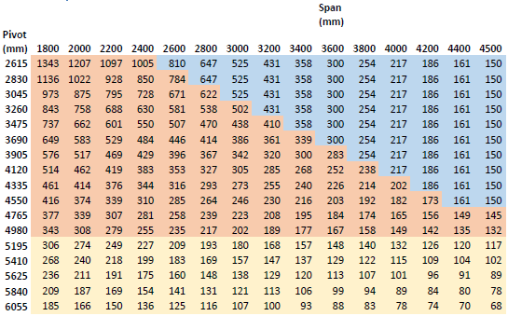

### Wind resistant up to:

120 km/hour

### Water drainage and rain rate:

The patio canopy can accommodate a rain flow rate that corresponds with a rain shower of intensity 0.04 l/s/m² to 0.05 l/s/m² lasting a max. of 7 minutes. This type of rainfall occurs every 2 years. (cf. Belgian rain statistics: NBN B 52-011)

## Guarantee

* 5-year warranty on the structure (all defects that may arise during normal domestic use and with regular maintenance)
* 5-year warranty on Somfy® automation
* 10-Year warranty on the colourfastness of the paintwork of the aluminium profiles.
* 5-year warranty on sheen (paintwork):

## Options

### Up/Down LED lighting:

Integrated LED lighting on the inside of the framework over the compete length fitted with upward and downward lighting.

* Up:
  + Warm white light 120 LEDs/M | +/-2800K | 550-680 lumen/m
  + Pure white light 120 LEDs/m | +/5000K | 550-680 lumen/m
* Down:
  + Warm white light 120 LEDs/M | +/-2800K | 550-680 lumen/m
  + Pure white light 120 LEDs/m | +/5000K | 550-680 lumen/m
  + RGB 60 LEDs/m | 550-700 lumen/m

## Standards

This product has been made, meets and/or has been tested in accordance with the standard: EN 13561